SEAM UNIT

2019

Don’t Judge a Book by its Cover

ATFA 6300
Authored by: Chalese Craig

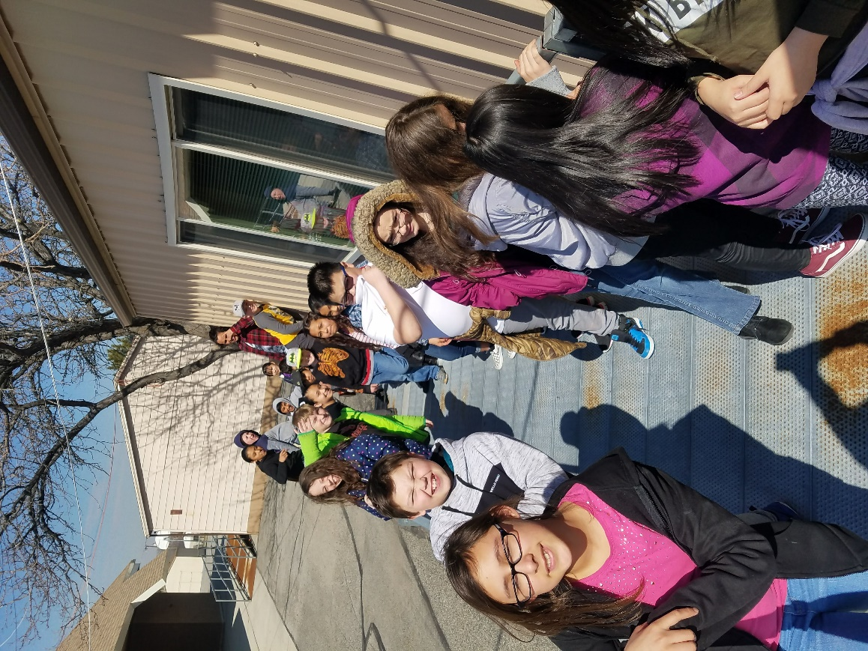

SEAM PROJECT SUMMARY

Every other week for the past ten weeks I have met with Christine Olcott’s sixth-grade class at Robert Frost Elementary to develop a Socially Engaged Art Making Project. Meeting every other week has been a challenge. Last semester I worked with the other sixth-grade class at Robert Frost to make videos for my Art in Action Final project for ATFA 6200. We created Adobe Spark Video’s to share the importance of Kindness. I shared these videos with most of my art classes at Frost Elementary. Initially, I imagined the class would end up doing something about Ecology for Earth Day which is the same week as the Art Night they decided to present at.

After we discussed the results of the topic survey that I made for the project, it was clear that they, like my class last semester are concerned about how much contention and division is happening in the world we currently live in. They voted in class on doing a piece of art about treating everyone the way you want to be treated. We couldn’t agree on a title until one brilliant girl in the class mentioned “Don’t Judge a Book by its Cover” and the whole class after exploring the options agree this would be a great thing to share with the fellow students at Robert Frost Elementary, the parents of the students and the staff of the school.

They decided the best way to share them would be to take pictures and make videos sharing the message that you need to get to know someone to really know them and you can’t judge a person by their appearances. The members of our SEAM team decided that we will be posting the videos on my teacher website
https://ccraig.weebly.com/. We will also be sharing them at the School Art Night on April 25th with the help of our school Technology Specialist Kathleen Riebe.

DEMOGRAPHICS

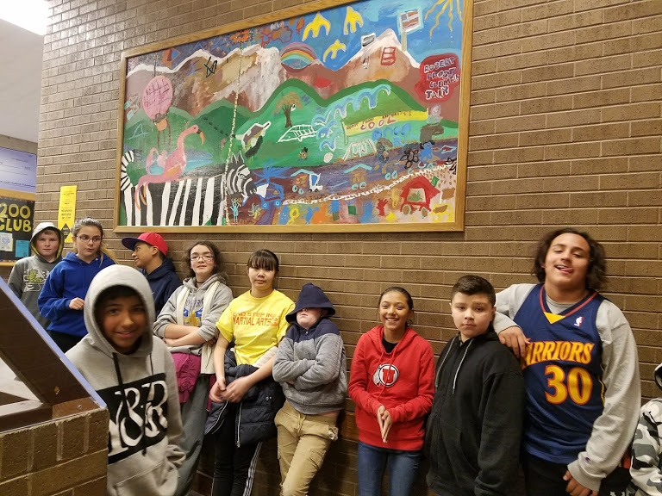
The SEAM team- Mrs. Olcott’s class at Robert Frost Elementary. I have taught this class both visual art and ukulele every other week this school year. I feel as though because they are one of two classes I see twice in one week, we have built up a relationship of trust this year that has benefited this art making process.

Robert Frost Elementary School
Students- 484
Gifted Students- 2.5%
Female -47%
Male - 53%

Student Diversity
White - 53.1%
Hispanic – 30.7%
Asian- 5.4%
Pacific Islander -5.2%
Native American -2.9%
African American-1.7%
Multiracial-1.4%

WEEK ONE
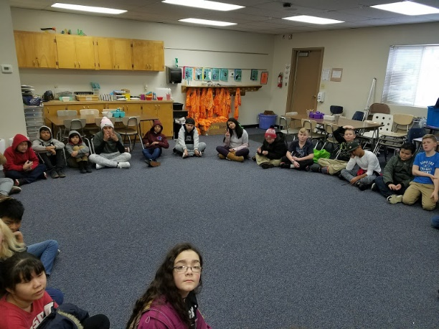
COMMUNITY BUILDING
Trust, belonging, risk-taking, ensemble
Lesson Narrative: I only meet with these students twice a month so we have already started discussing possible topics for our SEAM project so we can speed up the process. We completed this lesson on Friday, January 18th.
Lesson Title: Building our SEAM Team Week One.
Content Objective: Students will build as a group a safe place to make art. They will develop respect in our group so that we can work on the skills in the below drama and social studies state standards.
Student Learning Outcome: We will get up to twenty on the group counting game and complete our bean bag tossing pattern in under one minute.
Grade Level: 6th Grade
Lesson Duration: 45 minutes
Materials: Bean Bags and or other balls for tossing.

Instructional Plan
1) Create – We will create a tossing pattern with a bean bag. Everyone will remember who tossed the bean bag to them and who they tossed the bean bag to and repeat that process as a group until we can do it with limited drops under a minute. (We made it!)
We will play the group counting game. Someone starts the game and we count one person at a time as high as we can without more than one person at a time saying each number. (We will be doing this every time we meet possibly. It was a great activity for this group. They struggled with listening and waiting.)
2) Perform/Present- Perform the tossing pattern in under a minute. Count to twenty without any interruptions.
3) Respond- After we talked about what SEAM is a little bit, set expectations for group discussion and played our two games we talked about how the games help us as artists and team members making art together. They mentioned listening and respect.
4) Connect/Analyze Assessment (formative/summative): Completion or improvement of cooperation in the games.
Differentiation/Adaptations: I am going to try both games in two smaller groups next time.
PROGRESSIONS: PROGRESSIONS: With this being the first part of a six part lesson unit we will be building off of the team we build and the discussion we stat in this first lesson.
LIFE SKILLS: This lesson focuses on the development of our SEAM team. We will be practicing social skills and developing social intelligence.
SEAM lesson goal: The goal of this project for me is to give these children an experience thinking outside of themselves and to think about the world they live in, and what they can change or want to change in that world. I also wish for this group of kids to be an example to the other children at their school.

Reflection of Lesson

I think these kids will benefit from playing the drama games. I really want to make sure the focus of this whole experience it on helping the chosen audience to see things in a new perspective. They really started to get into it. I am hopeful that this process with be a success.

WEEK TWO
THEME IDENTIFYING
Issues, skill inventories, contract building

Content Objective: Decide on one to three options for our SEAM Project message and discuss the possibilities and art we could make and how we could present this art.

Student Learning Outcome: We will decide on current global issue to address with our art making.

Grade Level: 6th Grade
Lesson Duration: 45 minutes
Materials: White board and examples of SEAM projects.

Instructional Plan
- Perform/Present- We will sit in a circle and each person will communicate what they would change in the world if they could. It could be in their class, our school, our community, our state, the country or the world. We will document the answers. We will also tell the circle what we bring individually to this experience that is helpful.
- Create- We will decide on the art form and materials for our creation.
- Respond- Students will make a list of possible topics for our SEAM project. We will then discuss the possibilities and come to consensus/conspectus on a topic for our piece.
- Connect/Analyze Assessment (formative/summative): We will have a topic for our SEAM project.
- Differentiation/Adaptations: Students can choose to say whatever they want about the piece if they can’t figure out the answers to the above questions. They can also pass and not participate in that portion of the exercise.

Reflection of Lesson

The students needed some serious guidance during our discussion. They brought up topics that would not be appropriate for school. I feel as though they are starting to see how this project can impact the school. Many of them are worried about pollution to our earth and they also are very aware of the contention in this country. They talked nonstop about racism and many of them even have seen it firsthand. I think we made some great progress.

WEEK THREE

ISSUE MINING
research, thoughts, feelings, intentions, joint action
Content Objective: Pick our SEAM project topic.
Student Learning Outcome: We will decide on current global issue to address with our art making.

Grade Level: 6th Grade
Lesson Duration: 45 minutes
Materials: White board and examples of SEAM projects.

Instructional Plan
Perform/Present- We will sit in a circle and talk about the final three possible topics we chose last week. We will also look at the surveys they took to help us develop a list of possible issues they want to address, and come to a consensus of what will be the message we want to send.
Create- We will decide on the art form and materials for our creation to be ready for the next weeks art making.

Respond- We will discuss the impact we desire and start to plan where, when and for who we will present our piece.
Connect/Analyze Assessment (formative/summative): We will have a topic for our SEAM project.
Differentiation/Adaptations: Students can choose to say whatever they want about the piece if they can’t figure out the answers to the above questions. They can also pass and not participate in that portion of the exercise.

PROGRESSION: We will practice some team building games, and finalize our project name, our audience our art form and when and where we will display or perform.
LIFE SKILLS: This lesson focuses on the development of our SEAM team. We will be practicing social skills and developing social intelligence.
SEAM: The goal of this lesson is to help the students see that each of them has the power to enact change in the world around them. I also want to make sure the topic, media, audience and share space is thoughtfully selected. The tricky part of this step in the process is to help them see the “how” we will execute the project not just the “what” we will have as an end product. We have time and resource restraints that will hinder some of their ideas.

Reflection of Lesson

I feel as though it was a long road to narrowing down consensus on our topic, but the second one girl suggested “Don’t Judge a Book by its Cover” everything seemed to come together for us. I don’ know exactly how we will make this into a message for our school because it is slightly vague, but I am hopeful. They have chosen to make videos like Mrs. Gelas’ class did last semester. I worry that this lesson will be a repeat of last semester’s project. I have made a goal to make this project special and unique for this group of students.

WEEK FOUR

ART MAKING
Analyzing, choosing, merging, forming, meaning making

NARRATIVE: We will finally be creating art this week. The class decided to have our theme be “Don’t Judge a Book By its Cover.” Many of the students expressed their concerns with prejudice and bigotry so when this title was suggested by one of the students was a fast favorite of the class. This week we will be learning a little bit about what makes a great photo, basic photography principles and we will go outside to practice taking photographs. I brought in a version of the “I am” poem and made a slide for the poem “People Equal.” I will show this to them one of these options or both may accompany their videos well.
Lesson Title: Don’t Judge a Book by its Cover

Content Objective: Students will start building, writing or developing their SEAM piece that they developed the three prior weeks.
Student Learning Outcome: Work collaboratively on our piece of art.
Grade Level: 6th Grade
Lesson Duration: 45 minutes

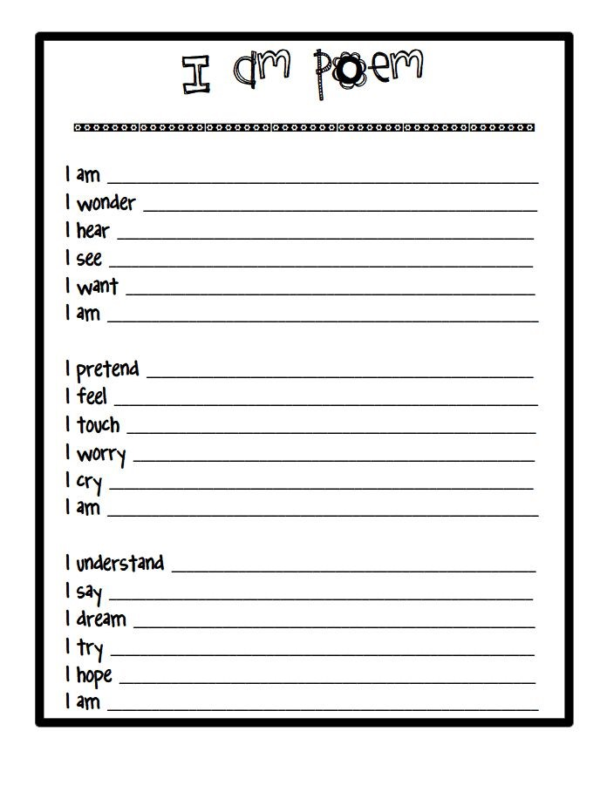
Materials:
- People Equal poem by James Berry, I am poem black line.
- I am Not Black YouTube Video- https://youtu.be/q0qD2K2RWkc (Links to an external site.)Links to an external site.
- What Makes a Great Picture video What Makes a Great Picture? | National Geographic (Links to an external site.)Links to an external site.
- Cameras, ipods or phones to take pictures.

Instructional Plan
1) Create –Today we will fill out a “I Am” poem form, look at the poem “People Equal” by James Berry and determine which could serve as our dialogue for our videos. We will watch the YouTube video from National Geographic about what makes a great photo and go outside and play with light and composition.
2) Perform/Present- We will present the piece at Art Night at the end of April.
3) Respond- We will have a reflective portion at the end of each class where we can respond to our process, celebrate our progress and even highlight each other’s efforts.
Differentiation/Adaptations: We will make a point in finding something for every team member to do. We will establish that as one of our first priorities.
PROGRESSION: Will begin our journey as photographers. Our desire is to illustrate that you cannot judge a person by looking at the surface.
LIFE SKILLS: This lesson focuses on the development of our SEAM team. We will be practicing social skills and developing social intelligence. This lesson gives them many chances to work as a small group and communicate with one another.

The Survey

PEOPLE EQUAL
Some people shoot up tall.
Some hardly leave the ground at all.
Yet-people equal. Equal.
One voice is a sweet mango.
Another is a nonsugar tomato.
Yet-people equal. Equal.
Some people rush to the front.
Others hang back, feeling they can't.
Yet-people equal. Equal.
Hammer some people, you meet a wall.
Blow hard on others, they fall.
Yet-people equal. Equal.
One person will aim at a star.
For another, a hilltop is too far.
Yet-people equal. Equal.
Some people get on with their show.
Others never get on the go.
Yet-People equal. Equal.
-James Berry

Reflection of Lesson

To get them to think about judgement in their lives I thought we should start with reflection. I wanted them to see what makes them a great individual. I added the poem to illustrate that we are equal and all important even though we are different. I saw this as a structure to build upon for our lesson and leading up to the photography and video making. I feel as though it gave them some motivation and perspective.

WEEK FIVE

STRUCTURE SETTING
Seaming, rehearsing, editing, polishing

NARRATIVE: We will be starting our videos for our piece. We have started taking pictures for the slideshow videos. We will be taking more pictures, learning the Adobe Spark program, making a test video with a few tasks and if we have time we will start downloading the pictures we took for our “Don’t Judge a Book By its Cover” videos. We have written our own “I Am” poem and we have been introduced to the People Equal poem by James Berry. They can use these to help with their video narration.
Lesson Title: SEAM in action- “Don’t Judge a Book by its Cover.”

Content Objective: Students will complete their group videos and submit them to be uploaded, thus showing teamwork and their knowledge of photography.
Student Learning Outcome: Work collaboratively on our piece of art about refraining from judgement and not judging a person from your first impression.

Grade Level: 6th Grade
Lesson Duration: 45 minutes
Materials: Computers for each group at least, USB cords and smart phones

Instructional Plan
1) Create – We will create group slide show videos using Adobe Spark.
2) Perform/Present- We will try to have it finished for the April 22nd art show for the whole school.
3) Respond- We will have a reflective portion at the end of each class where we can respond to our process, celebrate our progress and even highlight each other’s efforts.
Differentiation/Adaptations: We will make a point in finding something for every team member to do. We will establish that as one of our first priorities.
PROGRESSION: We will continue to build and refine our SEAM project.
LIFE SKILLS: This lesson focuses on the development of our SEAM team. We will be practicing social skills and developing social intelligence.

Reflection of Lesson
I am predicting week 5 will take multiple weeks to finish. This project will most likely be finished just in time for our art show which is at the end of April. We have started to use our weekly ukulele time to help us finish our project. We have ample photos for the videos, but we have experienced many setbacks transferring the photos from their phones and the students kept having issue with the website. They couldn’t log in, and then because of connectivity and power issues in the building the internet kept crashing. The teacher hasn’t stayed in to help so I am on my own putting out fires. Last week I had planned on leaving my other school on Friday to go back to Robert Frost to help the students fix their issues and get closer to finished or completed. That did not work out. Mrs. Olcott on the other hand had the students take pictures with the ipods to help us transfer the media easier.

WEEK SIX

COMMUNITY SHARING
Exhibiting, performing, reflecting, documenting, evaluating

Lesson Title: Don’t Judge a Book by its Cover

Content Objective: Upload their videos to my school website. Ccraig.weebly.com

Grade Level: 6th Grade
Lesson Duration: 45 minutes
Materials: Ipods, computers, videos about photography.
What makes a great photo- https://youtu.be/v3HDI0cUkZk
Mobile photography tips- https://youtu.be/Fem4gL0n4kk
Instructional Plan
Create – We will have created videos to share with our community.

Perform/Present- We will upload the videos we have made to my website. I will share them with the classes at Robert Frost Elementary. On April 25th 2019 we will project them on the screen during our school art night.

Respond- In our last discussion we realized that we are all frustrated with the past few meetings in the computer lab. The class has the skills to finish they say, but we keep meeting obstacles way.

Differentiation/Adaptations: We will make a point in finding something for every team member to do. We will establish that as one of our first priorities.
PROGRESSION: We will continue to build and refine our SEAM project. This week is the goal for finishing the project. We will get the piece ready to upload to ccraig.weebly.com
LIFE SKILLS: This lesson focuses on the development of our SEAM team. We will be practicing social skills and developing social intelligence.

Reflection of Lesson

Narrative: We have had many setbacks on our road to competing the project. I am quite frustrated at some of the mistakes I made in letting the kids use their phone in which they couldn’t find their photos on instead of letting them use the Ipods that we all know how to transfer pictures from. I wish the teacher would have stayed to help a time or two. We will make these videos. The kids are getting really good at the program! The students have worked so hard! I feel as though they have learned lessons I didn’t plan on, like persistence, working with people in class you regularly don’t collaborate with and being part of a team while things out of our control happen. I have loved seeing the kids get more and more adamant about how hurtful judgement is. I have also loved seeing them create videos using ingenuity when some of their photos wouldn’t upload onto their computers.

